Addressing the Shortage of Teachers and Lack of Laboratory Facilities for Higher Education Students in Rural Sri Lanka.

# Executive Summary

This proposal presents a strategy to improve the quality of science education for higher education students in rural Sri Lanka, focusing on the challenges of teacher shortages and lack of laboratory facilities. The education system in many rural areas faces these significant barriers, which limit A/L students' access to quality education, particularly in science and mathematics. As a result, students' academic development is hindered, and they cannot develop critical skills required for future academic and career success.

This project will address these challenges by providing teacher training programs and introducing virtual lab technologies. These interventions aim to equip teachers and students with the tools needed to enhance educational outcomes. By improving the quality of teaching and providing hands-on learning experiences, the project intends to foster critical thinking, creativity, and problem-solving skills among students, ultimately preparing them for success in higher education and the workforce.

Table of Contents

Executive Summary 2

Introduction 4

Current situation leading to problem identification 5

Proposed Technique to Solve the Current Problem 7

Feasibility 9

Project Description 11

Deliverables 12

Resources Required 14

Expected Output and Outcome 17

Time plan for implementation 19

Limitations 20

References 21

# Introduction

Science education in rural Sri Lanka faces considerable challenges, primarily due to a shortage of qualified teachers and a lack of well-equipped laboratories. In these regions, students often experience a poor quality of education, especially in critical subjects such as physics, chemistry, biology, and mathematics, which are essential for future academic and career success.

The shortage of trained science teachers exacerbates this problem, with many schools relying on teachers who may lack expertise in the subject matter. This lack of functional laboratory facilities severely limits students' ability to engage in hands-on learning. As a result, students struggle to apply theoretical knowledge in practical contexts, essential for developing critical thinking and problem-solving skills.

This project seeks to address these challenges by implementing a comprehensive intervention strategy, including teacher professional development and integration of virtual lab technologies. By addressing these gaps, the project will improve science education and provide students with the necessary skills to succeed academically and professionally.

# Current situation leading to problem identification

In many rural and underdeveloped regions of Sri Lanka, higher education students, particularly those studying science and mathematics, face significant barriers to accessing quality education. These barriers are primarily rooted in the lack of qualified teachers and insufficient laboratory facilities, limiting students' ability to fully engage with the curriculum and develop the critical skills necessary for academic and professional success.

1. **Teacher Shortage:**

Many rural schools in Sri Lanka struggle to attract and retain qualified teachers, particularly in subjects such as physics, chemistry, and mathematics. According to the Ministry of Education, the shortage of subject-specific teachers is a longstanding issue that is especially prevalent in remote areas (Ministry of Education, 2021).

Available teachers often lack specialized training in their subjects, leading to an education that is more theoretical than practical. This teacher expertise gap severely impacts instruction quality and leaves students with a limited understanding of key scientific concepts.

1. **Lack of Laboratory Facilities:**

Laboratory facilities are essential for science education as they allow students to apply theoretical knowledge in practical settings. However, many schools in rural areas lack fully equipped laboratories, limiting students’ ability to conduct experiments and gain hands-on experience.

Without laboratory access, students cannot observe, experiment, or verify scientific principles for themselves.

This lack of practical learning experiences makes it difficult for students to develop critical thinking, problem-solving, and experimental skills, all essential for success in science-based fields.

In schools where laboratories exist, the equipment is often outdated or in disrepair, further hampering students' ability to engage in practical science education.

1. **Impact on Student Engagement and Performance:**

The combination of unqualified teachers and the lack of laboratory facilities results in disengaged students who cannot see the practical applications of what they are learning. This lack of engagement contributes to poor academic performance in science subjects, reducing students’ chances of pursuing higher education in science, technology, engineering, and mathematics (STEM) fields.

The inability to develop critical thinking and problem-solving skills in science also affects students’ broader academic abilities and career prospects. Students who are not allowed to apply their knowledge through hands-on experiences are often unprepared for future challenges in higher education or the workforce.

The current situation in rural Sri Lanka is characterised by a severe lack of qualified science teachers, inadequate or non-existent laboratory facilities, and a curriculum that fails to engage students in meaningful, practical learning.

# Proposed Technique to Solve the Current Problem

This proposal outlines a multi-faceted approach that includes teacher training and technology integration through virtual labs to address the critical issues of teacher shortages and lack of laboratory facilities in rural schools. The aim is to provide teachers and students with the resources and support they need to enhance science education, foster creativity, and build essential skills.

1. **Teacher Training and Professional Development:**

* **Workshops and Online Courses:** Teachers will participate in specialized seminars and online courses focused on effective science teaching methods, including inquiry-based and project-based learning (Simms, 2016).
* **Subject-Specific Training:** Teachers will also receive in-depth training in chemistry, biology, and physics to ensure they have the expertise to teach these critical subjects confidently.
* **Mentorship and Continuous Support:** A mentorship program will be introduced, where experienced teachers and education professionals can provide ongoing support and guidance to rural teachers.

1. **Integration of Virtual Labs:**

* **Virtual Lab Software:** Virtual lab simulations will be introduced in schools where physical lab facilities are unavailable or inadequate. These virtual labs will allow students to conduct experiments and explore scientific phenomena in a simulated environment, bridging the gap between theoretical knowledge and practical application. Virtual labs will be aligned with the national curriculum, ensuring that students can perform experiments and gain insights into complex scientific concepts, even without access to physical labs.
* **Blended Learning:** The project will implement a blended learning approach that combines physical lab experiences with virtual lab simulations. This will help students develop both theoretical and practical knowledge, ensuring they are well-equipped for higher education and future careers in STEM fields.

1. **Student-Focused, Project-Based Learning:**

* **Inquiry and Project-Based Learning:** Students will engage in project-based learning activities where they design and conduct their experiments. This approach fosters creativity, critical thinking, and collaboration while also improving students’ ability to apply scientific principles in real-world situations.
* **Science Fairs and Innovation Challenges:** To further engage students and encourage creativity, science fairs and innovation challenges will be organized at the school and regional levels.

1. **Monitoring and Evaluation:**

* **Continuous Feedback:** Regular feedback from teachers and students will be collected to monitor the project's progress. This will help identify areas for improvement and ensure that the interventions effectively address the issues identified.
* **Assessment of Student Performance:** Student academic performance will be tracked over the course of the project, focusing on improvements in science subjects.

# Feasibility

The feasibility of this project depends on several factors, including resource availability, institutional support, scalability, and potential sustainability.

**Resource Availability**:

* Human Resources: The project will rely on existing educational professionals for training, including local teacher trainers and subject matter experts.
* Technology Resources: Virtual labs and digital platforms for learning are becoming increasingly accessible. Many open-source platforms offer free or low-cost educational simulations that can be integrated into the project without incurring substantial costs.

**Institutional Support:**

* Government and Education Ministries: The Ministry of Education in Sri Lanka has expressed a growing interest in improving rural education. With their support, teacher training programs can be easily coordinated at the regional level.
* Local Schools and Educational Bodies: Schools and local education authorities are likely to welcome initiatives to improve education quality. Their support will be crucial for facilitating teacher participation and the distribution of learning resources.

**Scalability:**

* Adaptable Model: The intervention model, which includes teacher training and virtual lab integration, can be scaled to other schools and regions once the pilot phase demonstrates success. The model is flexible and can be adapted to meet the specific needs of different rural areas.

**Potential Barriers:**

* Teacher Resistance to Change: Some teachers might initially resist new teaching methods or technologies. However, this can be addressed through proper training, ongoing support, and demonstration of the benefits of the latest methods in terms of student engagement and academic performance.
* Access to Technology: Some rural schools may still lack primary internet access or technological infrastructure. To address this, the project will explore offline virtual lab options and ensure that schools are equipped with the necessary tools to engage with digital resources.

# Project Description

This project aims to tackle the critical issues of teacher shortages and inadequate laboratory facilities in underdeveloped regions of Sri Lanka. Implementing a multi-faceted approach, the project seeks to improve access to quality mathematics, physics, chemistry, and biology education.

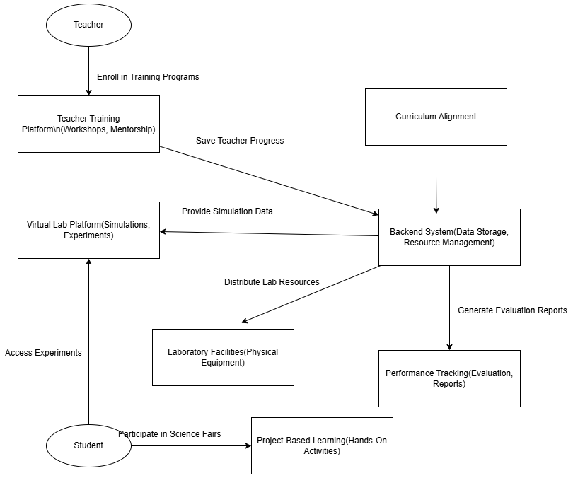

# Deliverables

|  |  |  |  |
| --- | --- | --- | --- |
| **Category** | **Deliverable** | **Description** | **Expected Output** |
| Teacher Training and Development | Teacher Training Website | A platform for delivering interactive courses, workshops, and seminars focused on inquiry-based and project-based learning methodologies for science teachers. | Recruiting teachers and implementing training programs |
| Subject-Specific Online Courses | Online courses focused on in-depth training in chemistry, physics, and biology for teachers, including video lessons, quizzes, and interactive content. | Teachers gain mastery of subject content through the software. |
| Mentoring Program Platform (App) | This includes an app-based system that connects teachers with experienced mentors who provide ongoing professional support through messaging, video calls, and collaboration tools. | Matching with teachers and mentors. |
| Virtual Lab Integration | Virtual Lab Software (Website and App) | Virtual labs hosted on a website or app for students to simulate science experiments in line with the national curriculum. | By students conducting virtual experiments. |
| Blended Learning App | A mobile app that combines in-person and virtual learning activities, allowing students to engage in experiments and track progress in real time. | Students engaged in blended learning. |
| Project-Based Learning | Project-Based Learning Platform | A website for students to share projects, conduct experiments, and collaborate on science topics in real time. | For submitting and sharing student projects. |
| Monitoring and Evaluation | Continuous Feedback Portal (App) | A feedback collection system for teachers and students to provide insight into the effectiveness of training, virtual labs, and learning activities. | Collecting and analysing feedback responses. |
| Student Performance Tracking System (App) | An application that tracks individual student performance in science subjects, allowing teachers and students to track academic improvement over time. | Monitoring students' academic progress. |
| Project Evaluation Reports (Website) | A digital reporting system that compiles data on the success of interventions (teacher training, student performance, virtual labs), providing insights and recommendations. | Detailed project evaluation reports for stakeholders. |

# Resources Required

To successfully implement the project, the following software and tools will be required for development, data monitoring, and virtual lab integration

1. Development Tools:

* Backend Development (Laravel):

Laravel will be used to build the server-side application, including user management, authentication, database management, and API integration.

Key Features: RESTful API, Authentication (Sanctum), Database

* Frontend Development (React):

React will be used to build a dynamic, interactive user interface for the teacher training website and student project platform.

Key Features: Single-page applications (SPA), Interactive user interfaces, Integration with backend API, Responsive design.

* Mobile App Development (React Native):

React Native will be used to develop cross-platform mobile apps for the mentorship platform, virtual lab interactions, and science fair registration.

Key Features: Cross-platform (iOS and Android), Native-like performance, virtual labs and backend integration.

1. Virtual Lab Development (Unity):

* Unity

Unity will create interactive, simulated science experiments in virtual labs. It allows the development of 3D environments for physics, chemistry, and biology experiments.

Key Features: 3D simulations, Real-time interactions, Integration with Unity’s physics engine, and exporting to web and mobile platforms.

1. Data Monitoring and Analysis (Python):

* Python

Python will monitor and analyse student performance, providing data-driven insights through data analysis libraries like Pandas, Matplotlib, and Scikit-learn for performance predictions and trend analysis.

Key Features: Data manipulation, Performance tracking, Data visualization, Machine learning.

1. Database:

* MySQL

This stores user data (teachers, students, projects), performance metrics, virtual lab activity logs, and feedback.

Key Features: Relational database for structured data, Transactions, Security, Data backup and recovery.

1. Other Tools/Resources:

* Git & GitHub:

Version control and collaboration for the development team.

* AWS / Hostinger:

For cloud hosting, the application and database.

# Expected Output and Outcome

|  |  |  |
| --- | --- | --- |
| **Category** | **Expected Output** | **Expected Outcome** |
| Teacher Training Website | A fully functional, responsive website for teachers to access courses and mentorship. Teachers can view modules, track progress, and receive certifications. | Teachers will gain expertise in science teaching methods through specialised training and mentorship, implementing better teaching practices. |
| Virtual Lab Platform | A web and mobile-based virtual lab for students to perform science experiments, simulating real-world scientific phenomena in physics, chemistry, and biology. | Students will gain hands-on experience even without physical labs, improving their ability to apply scientific concepts and develop critical thinking skills. |
| Student Project-Based Learning Platform | A dynamic platform for students to submit projects, collaborate with peers, and receive feedback from teachers and mentors. Students will create accounts, upload projects, and engage in real-time collaborative tasks. | The project-based learning platform will encourage creativity, problem-solving, and collaboration, enhancing students' practical and creative skills. |
| Data Monitoring System | A system for monitoring and analysing the academic performance of students, with visual reports and predictive insights on student progress in science subjects. Reports will track improvements, identify weak areas, and provide suggestions for further support. | Continuous monitoring and feedback will help track student progress, leading to improvements in science subjects, greater interest in STEM, and better academic outcomes. |
| API (Backend - Laravel) | A RESTful API to connect all front-end platforms (website, mobile app, virtual labs) with the backend, enabling seamless data transfer and user management. APIs for user authentication, project submissions, feedback, and real-time performance tracking. | The system will be scalable, allowing expansion to additional schools and regions, especially those with limited access to physical labs and qualified teachers. |
| Data-Driven Insights | Python-based data analysis for real-time feedback on teaching methods and student progress, including reports on performance trends, improvements, and recommendations. | The analysis will provide feedback on the effectiveness of teaching methods and allow stakeholders (government bodies and educational institutions) to make informed decisions for future improvements. |

# Time plan for implementation

|  |  |  |
| --- | --- | --- |
| **Week** | **Task** | **Description** |
| Week 1 | Project Planning and Setup | Defining project scope, installation repositories, basic environment setup for React, Laravel, Python, Unity |
| Week 2 | System Design & Documentation | Creating system architecture diagrams, database schemas, and API documentation. |
| Week 3 | Front-end Development (React) | Getting started developing UI components and layouts in React. Implementing React Router. |
| Week 4 | Backend Development (Laravel & Python) | Development of basic APIs and services in Laravel and Python (CRUD operations, authentication). |
| Week 5 | Unity Development | Starting Unity development for any 3D components required. Integration with the backend. |
| Week 6 | Front-end and Back-end Integration | Integrating React front-end with Laravel/Python back-end. Testing basic communication. |
| Week 7 | Unit Testing | Write and run unit tests for React components, Laravel API, and Python scripts. |
| Week 8 | Final backend integration | Final integration between React and Laravel/Python. |
| Week 9 | UI refinement and unified finalization | Improving UI/UX and optimizing front-end performance. |
| Week 10 | System Testing | Performing a complete system test. Identifying and resolving issues. |
| Week 11 | Deployment Preparation | Preparation of the application for product deployment. Deployment to the server/hosting platform. |
| Week 12 | Final Documentation and Launch | Finalization of all documentation (API, user guide, system design). Full deployment to production. |

# Limitations

1. Time Limits:

The 3-month timeframe can be tight, depending on the complexity of the features. Some advanced features or custom requirements may require more time to develop.

1. Resource Limitations:

Access to specialised technologies (UNITY virtual lab) can slow development.

1. Technical Challenges:

Potential issues such as API integration, database performance, or third-party service limitations can arise

1. Budgetary Limitations:

This may affect software license purchases or infrastructure setup.

1. Scope Creep:

New features or mid-project changes may delay the timeline or require additional resources.

1. User Feedback:

Incorporating feedback during testing can lead to unexpected changes that can push the timeline back.

# References

Ministry of Education, 2021. *2021 Annual Report English,* Colombo: moe.gov.lk.

Simms, V., 2016. *Mathematical mindsets: unleashing students’ potential through creative math, inspiring messages and innovative teaching.* [Online]   
Available at: https://www.tandfonline.com/doi/full/10.1080/14794802.2016.1237374  
[Accessed 15 11 2024].